**Justification of Chosen Method and Sources**

|  |  |  |
| --- | --- | --- |
| **Method** | **Advantages** | **Disadvantages** |
| *Interviews* | * Information at a greater depth. * Flexibility in restructuring the questions. * Non-response is far less than that of a questionnaire. * Additional information can be sought. | * Can gain bias information (if employee dislikes company). * Maybe more time-consuming. * The interviewee may be busy. |
| *Observations* | * Provide an unbiased view of the system. *Observers don't know how the solution works.* | * Time-consuming. * Expensive. * Provides a snapshot of the system within a specific time-frame.   + Time-frame is important.   + People act differently when being observed. |
| *Questionnaires & Surveys* | * Easy to administer. * Inexpensive. * Overall satisfaction can be easily gauged. | * Processing responses can be time-consuming. * Retrieving completed responses can be difficult because people aren't obligated. * Difficult to determine who filled out the survey, may not be legitimate. |
| *Interviews w/ Focus Groups* | * Richer data than surveys. * May shed light on responses not previously understood. (Can ask for more depth/explore.) * Smaller focus groups are preferable as more inclined to participate. | * Documentation can be tedious.   + - However, scribe pens & voice recorders make this easier. |

The source of data will be Rachele Pelosi, owner of The Blue Dog.

Having considered all the pros and cons of each data collection method, I have chosen to use the following three methods...

**Questionnaire** because it is useful for covering question points that do not require elaboration—yes or no questions especially—and is very easy to distribute. The responses are immediately fed-back and the process of interpreting the user-base’s satisfaction with the current system is straight forward. I will specifically utilise a questionnaire to hasten the process of data collection by using the responses as a basis for elaboration during the interview. The complications of retrieving data via questionnaire—poor response rate and limited depth/elaboration of questioning—are combatted by the use of an interview.

**Interview** because the ability to expand on and dive deeper into questions raised in the questionnaire is crucial to a complete data collection. It is possible to seek out additional information when more clarity is required and change the direction of the interview should new information negate the necessity for certain question topics (for example; if it is found that only one user uses the system, all multi-user related questions are discarded). Though there is a possibility of biased data being collected, between the benefits of an interview and the use of an observation, the disadvantages are outweighed.

**Observation** because it provides an unbiased view of the operation and use of the system. The user cannot inject their opinions into their actions and the observer has no knowledge of how the system functions. Although observations are typically time-consuming and expensive, that will not be the case for me as I only have one user to observe. Additionally, the specific time will not affect the observation as the system in question is not used over long periods of time (longer than the observation). Therefore the pros of this collection method are more significant than its cons.

**Questionnaire (Google Form)**

1. What information do you need to make a finished roster? (e.g. Employee names, preferred shifts, pay rates, contact details?) *[written answer]*
2. How are employees informed of their shifts/how is the roster sent? *[written answer]*
3. Are past rosters stored on file/archived? *[yes/no]*
4. If so, how often and with what speed and ease do you need to access archived rosters? *[written answer]*
5. Does anyone else have access to the roster system? If so, whom? *[written answer]*
6. Are employee's personal data protected? If yes, how so? (e.g. key for a filing cabinet, password on photos) *[written answer]*
7. What information is displayed on a completed roster? (Shift times, employees, hours?) *[written answer]*
8. How long does it usually take to create a roster? *[written answer]*

**Collected Answers**

1. Employee names, availability, and if they’re able to open/close the cafe.
2. The roster is photographed and sent via Facebook/SMS or is printed and physically posted in the cafe.
3. Yes, they are archived.
4. Not often, but speed is required due to the circumstances in which a search would occur. Great ease of use is preferable.
5. The chefs and some trusted managers have access to the system.
6. Personal data is not collected and therefore nothing is protected.
7. Employee names and allocated shifts.
8. Roughly half an hour.

**Interview Questions**

1. Who has access to the system?
2. What task does each user/group perform?
3. Do any users/groups have special permissions?
4. What data goes into the system?
5. What data comes out of the system?
6. How is the data inputted to the system?
7. How is the data outputted from the system?
8. Where does the data come from?
9. Where does the data go?
10. What data is stored?

**Collected Answers**

1. Rachele, the chefs, and trusted managers.
2. Everyone creates rosters (only one per week), and Rachele finalises/approves rosters.
3. Only Rachele can send the final roster.
4. Employee names, availability, and if they’re able to open/close the cafe.
5. Employee names and allocated shifts.
6. Employees inform Rachele of their availability and their names. Their ability to open/close the cafe is stored on file and updated with their experience.
7. The final roster is photographed and sent digitally or printed and posted in the cafe.
8. Input data is sourced from employees.
9. Output data is destined for the roster delivery system (Facebook, SMS, or physical posting).
10. Employee names, availability (prefered hours), whether they can open/close the cafe, and past rosters (stores separately).

**Observations**

*Notes collected during observation:*

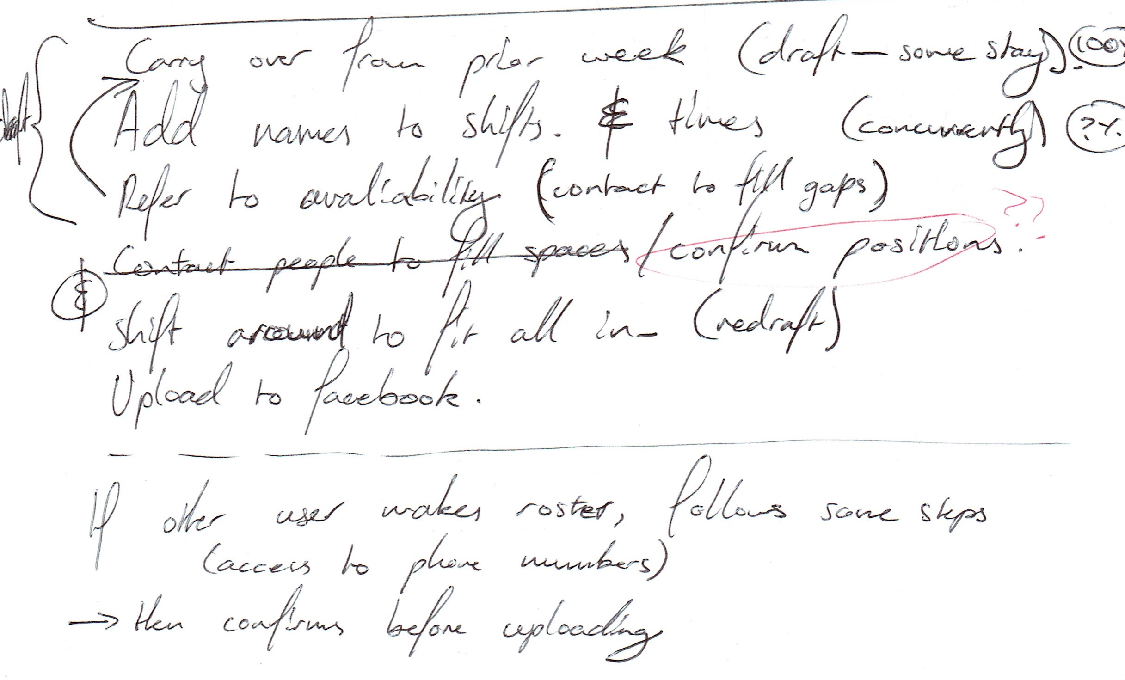

**Analysis Tools**

**Use Case Diagram**

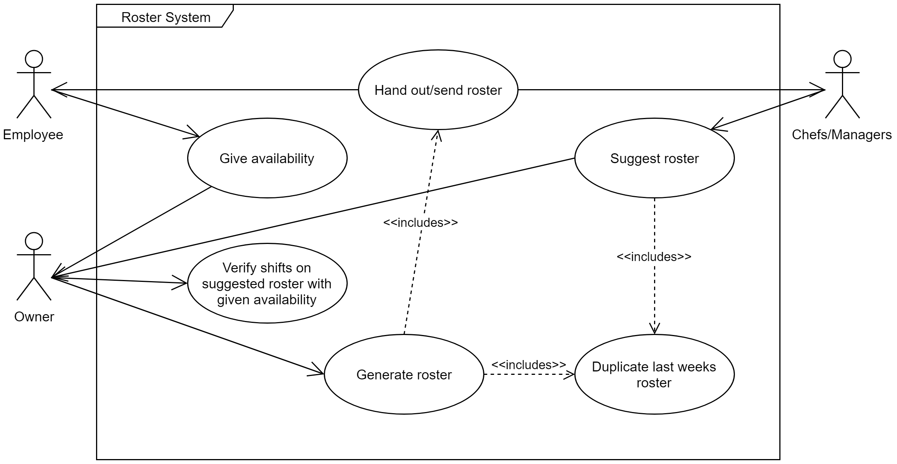

**Context Diagram**

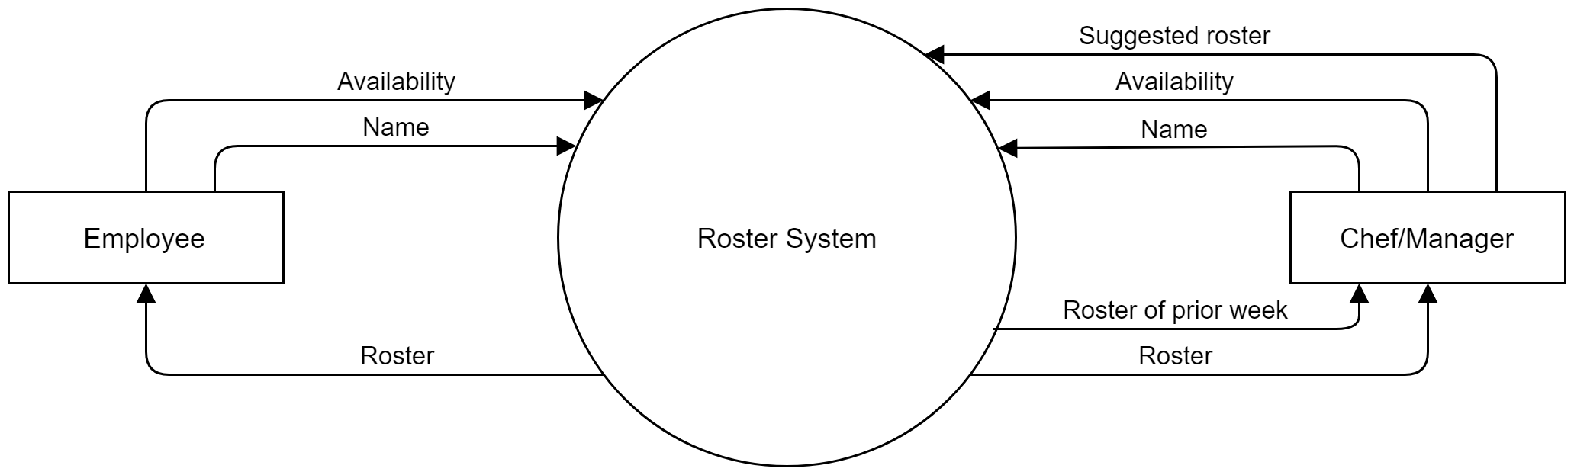

**Data Flow Diagram**

